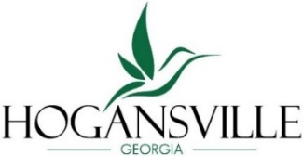
City of Hogansville
Downtown Development Authority
Meeting Agenda

Tuesday, January 27, 2026 at 6:00 pm
City Hall, 111 High Street, Hogansville GA 30230
Chairperson: Shareen Barker 2028
Vice-Chair: Kent Berus 2028 Treasurer: Keisha LeMay 2028
Board Member: Kandis Strickland 2026 Board Member: Tamara Manross 2028

;T

Call to Order
Agenda
- Approval of Agenda
- Approval of Minutes – November 25, 2025
Finance Report – Keisha LeMay
New Business
- Chair, Vice Chair, and Treasurer appointments
- Winter Market/Parade date
Committee Reports
- Organization – Engaging the community to plan and shape Main Street
- Design – Physical image of Main Street
- Economic Development – Strengthening businesses and revitalizing spaces
- Promotions- Marketing Main Street through ads, events, and activities
Upcoming Events

Next Meeting – February 24, 2026 – 6:00 pm

Adjourn

